BHIM App User Guide
Version 1.0 – September 2025

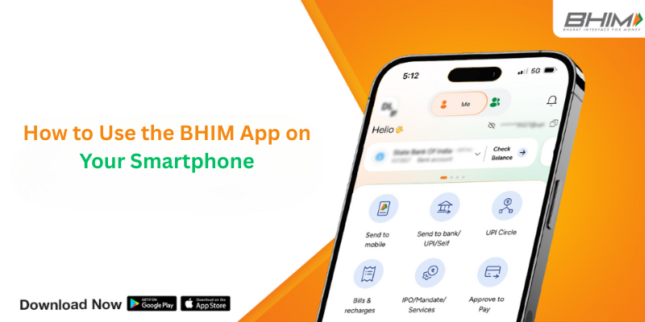

Creating a Step-by-Step Configuration Guide for the BHIM App

Contents
Creating a Step-by-Step Configuration Guide for the BHIM App 1
Introduction to the BHIM App 2
Benefits of the BHIM App 2
Configuring the BHIM App 2
Sending money through the BHIM App using a Mobile Number 3
Collecting money through the BHIM App using a Mobile Number 4
Scanning & Paying using the BHIM App 5
Resetting/Changing UPI PIN on the BHIM App 6
Troubleshooting Tips for the BHIM App 7
I have sent money but the transaction failed and my account is debited. What should I do? 7
I performed a transaction but it is showing pending. What should I do? 7
The money was sent to the wrong receiver. Can I reverse the transaction? 7
Conclusion 8
Frequently Asked Questions 8
What exactly is BHIM? 8
Who can use BHIM? 8
Is BHIM available for all handsets and operating systems? 8
What is UPI? 8
What is UPI PIN? 8
How do I set my UPI pin? 8
What is VPA? 9
How do I create my VPA? 9
What is Request? 9
Is there a limit on the amount of money that can be received using BHIM? 9
What methods are available on BHIM for sending money? 9
Is there a limit to the amount of money that can be sent using BHIM? 9

Introduction to the BHIM App
BHIM (Bharat Interface for Money) is a well-known payment app that enables quick and convenient transactions through the UPI (Unified Payments Interface). The BHIM app allows users to make direct bank payments to people using UPI by leveraging their UPI ID or scanning their QR code. Furthermore, this payment app provides the feature to request money from a desired UPI ID, thus, improving the overall convenience of financial transactions.

Benefits of the BHIM App
- A single app comes in handy to send and receive money and make vendor payments.
- Users can go cashless anywhere, anytime.
- Enables real-time money collection through single identifiers, resulting in reduced risks.
- Features an extra layer of security of single-tap 2-factor authentication.
- Requires mobile number or name to create VPA (Virtual Payment Address).
- Allows to send and collect funds using VPA or A/c no & IFSC code.
- Facilitates 24X7, 365 days instant money transfer.
- Best solution to Cash on Delivery problems.
- Supports 12 languages, including English, Hindi, etc.

Configuring the BHIM App
1: Find and install the BHIM app from the Google Play Store or Apple App Store.
2: Select your choice of language.
3: Choose a SIM with a phone number registered with your bank account.
4: Login by setting a 4-digit password for the application.
5: Link your bank account with the help of the bank account option.
6: Set a UPI PIN using the last 6 digits and the expiry date of your debit card.
NOTE - Be careful about entering a number that you can remember.
7: Go to the Profile section and create VPAs (2 VPAs are allowed per user, like name@upi and surname@upi).
8: Make one VPA your primary virtual payment address (for example, name@upi).
9: Scan and Pay through QR codes to send and collect money anytime.
10: Send and receive funds using VPA, account number + IFSC code, and Scan & Pay options.

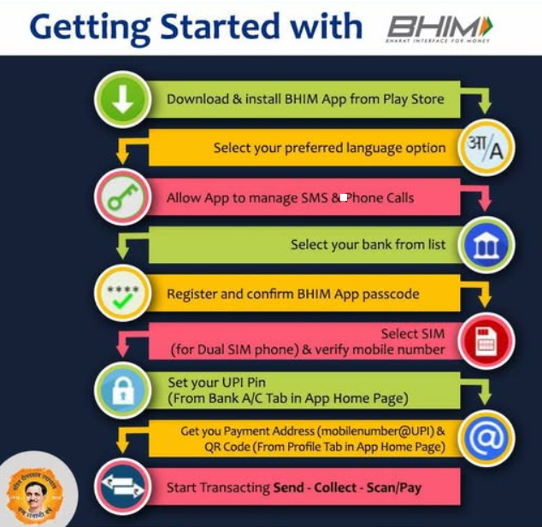

Sending money through the BHIM App using a mobile number
1: Open the app on your smartphone and enter the login code.
2: Choose the Send option.
3: Initiate a Send request.
4: Enter the mobile number of the payee and tap Verify to check their name.
5: Once the payee’s name displays, type the amount and remarks for the transaction and tap Pay.
6: Type your UPI PIN on the payment page.
7: View confirmation of the funds transferred to the payee.
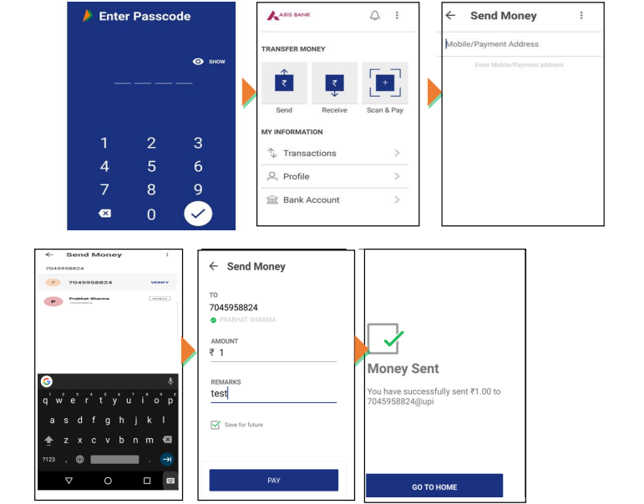

Collecting money through the BHIM App using a mobile number
1: Open the app on your mobile phone and enter the login code.
2: Choose the Receive option.
3: Initiate a Receive request.
4: Enter the mobile number of the payer and tap Verify to check their name.
5: Once the payer’s name displays, type the amount and remarks for the transaction and tap Pay.
6: Review confirmation of the request sent to the payer.
7: Once the payer accepts the request for money, you will get a notification.

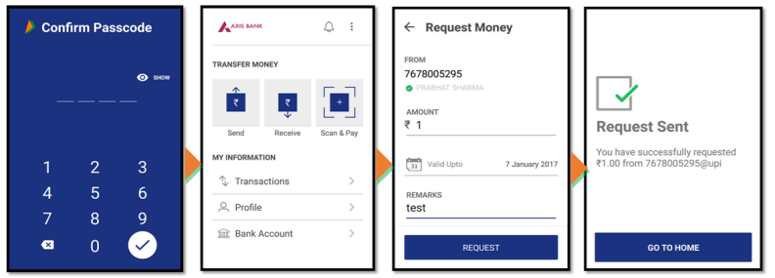
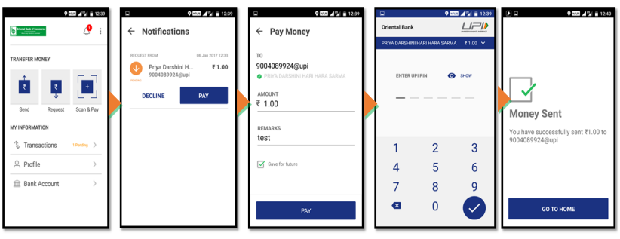

Scanning & Paying using the BHIM App
1: Launch the app on your device and enter the login code.
2: Choose Scan & Pay.
3: Scan the QR code of the merchant, prompting a Pay transaction screen.
4: Enter the amount and remarks for the transaction and tap Pay.
5: Type your UPI PIN.
6: See confirmation of the money paid to the merchant.
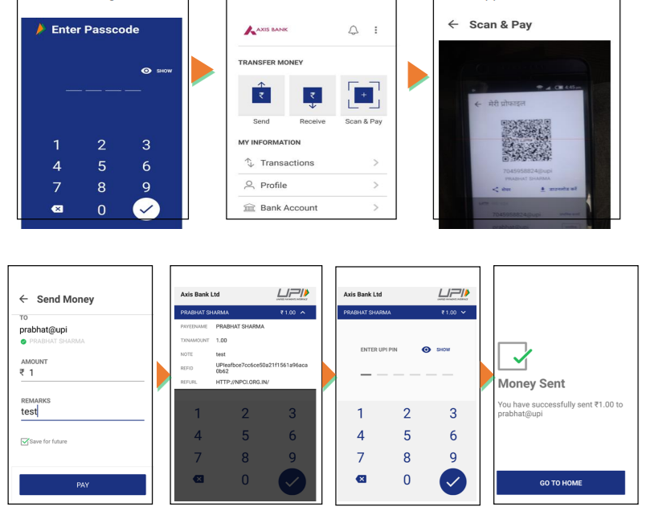

Resetting/Changing UPI PIN on the BHIM App
1: Select the Bank account option.
2: Tap SET UPI PIN.
3: Enter the last 6 digits and expiry date of your debit card.
4: Type the bank OTP received on your mobile number or wait for auto-detection.
5: Enter your new UPI PIN and reconfirm it.
6: A UPI PIN registration success message will pop up on the screen.

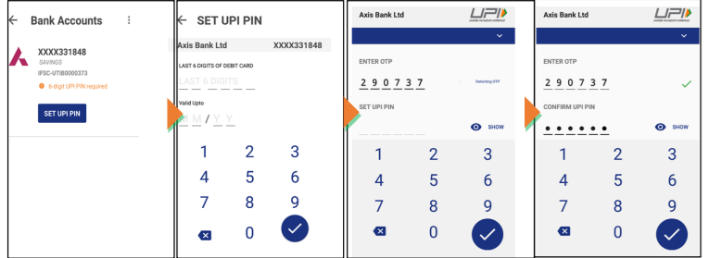

Troubleshooting Tips for the BHIM App
Here you will learn common techniques to deal with different challenges within the BHIM app:

I have sent money but the transaction failed and my account is debited. What should I do?
The transaction may have failed owing to an error in the system. The money is in the pool account of the transaction-initiating bank. You can seek information about this transaction from your bank using your transaction ID. In case you want to report a failed transaction, all you need to do is tap report issues and specify the details. The amount should be reversed to your bank account in T+3 days. If that doesn’t happen, you can visit here.
NOTE – A pool account is a financial arrangement that merges funds from various folks or entities in a single account. This enables more efficient banking and can be used to facilitate financial management.

I performed a transaction but it is showing pending. What should I do?
The transaction may have failed because of an error in the system. The money is available in the pool account of the beneficiary bank. You can seek information about this transaction from your bank using your transaction ID, which is also your reference ID. In case you want to report a pending transaction, it is advisable to tap report issues and specify the details on the transaction page of the BHIM app. The amount should be received by the payee in T+3 days. If that doesn’t happen, you can visit here.
NOTE – T+3 days refers to a transaction that will be settled three business days post the transaction date. “T” represents the transaction date, and “3” the number of days after that date when the settlement will take place.

The money was sent to the wrong receiver. Can I reverse the transaction?
NPCI acts as a platform for processing transactions. It allows instantaneous transfer therefore we request you to check beneficiary details carefully before making the payment. A successful transaction can’t be reversed unless the beneficiary refunds on its own.

Conclusion
BHIM UPI is one of the sought-after payment platforms in India, launched by NPCI in 2016 to improve financial inclusivity across the country. It allows users to send and receive money effortlessly using their registered mobile number, VPA, and account number & IFSC code. However, while executing payments, you must be familiar with all the reasons that can result in a decline in BHIM UPI transactions. Ensure to check carefully all the details you enter while processing a transaction. After evaluating the aforesaid reasons, you can easily discover why a BHIM UPI transaction failure may take place.

Frequently Asked Questions
For the unversed, we have compiled a list of frequently asked questions that users may want to learn answers to while making payments on the BHIM UPI app.

What exactly is BHIM?
BHIM is a UPI-driven payment interface that helps users transfer funds in real-time using a single identity, such as their name or mobile number.

Who can use BHIM?
Users having a smartphone and bank account are eligible to use the BHIM UPI app. However, you need to make sure that your mobile number is registered with the bank account and that a debit card is linked to that account. You can install the app from the Google Play Store or Apple App Store.

Is BHIM available for all handsets and operating systems?
BHIM UPI app can be used on all mobile phones with iOS and Android operating systems version 4 and above.

What is UPI?
The simplest way to understand UPI is that it is a payment method to transfer money between two parties. It is similar to other money transfer methods, like NEFT, RTGS, etc.

What is UPI PIN?
UPI PIN is a 4 to 6-digit number that is set by users on the BHIM app post the registration process. UPI PIN is used for validating all transactions done on UPI platforms, such as BHIM, *99#, and UPI apps.

How do I set my UPI pin?
Once you choose your bank account, you will be redirected to set your UPI PIN for the first time. It requires you to enter the last 6 digits of your debit card and expiry date.

What is VPA?
VPA (Virtual Payment Address) is a unique identifier that you can use to send and collect money on UPI.

How do I create my VPA?
After successful registration, a default VPA, i.e., mobno@upi will be created. You can add one more VPA by visiting the profile section.

What is Request?
If you wish to receive money from someone, you can initiate a collect transaction through the BHIM UPI app. The user who will get the request can decide to decline the request or make a payment by validating it with the UPI pin.

Is there a limit on the amount of money that can be received using BHIM?
No, there is no limit to the amount of money that you can receive using BHIM.

What methods are available on BHIM for sending money?
BHIM UPI app users can send money using one of the beneficiary's details:
- VPA (Registered on UPI)
- Mobile number (Registered on UPI)
- Aadhaar number (Should be linked to a bank account)

Is there a limit to the amount of money that can be sent using BHIM?
A customer can send money up to Rs 10,000 per transaction and a maximum of Rs 20,000 per day for one bank account. The limit is available per bank account linked on the BHIM UPI app.

